在navicat中新建查询，直接输入以下SQL新建视图，视图名自拟，查询的表数据和客户要求的字段根据实际情况进行修改。
以下红框中为视图所需字段
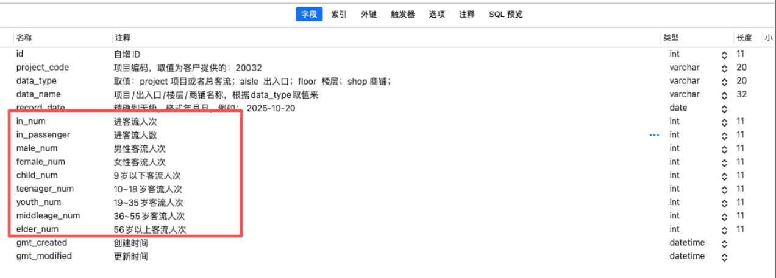
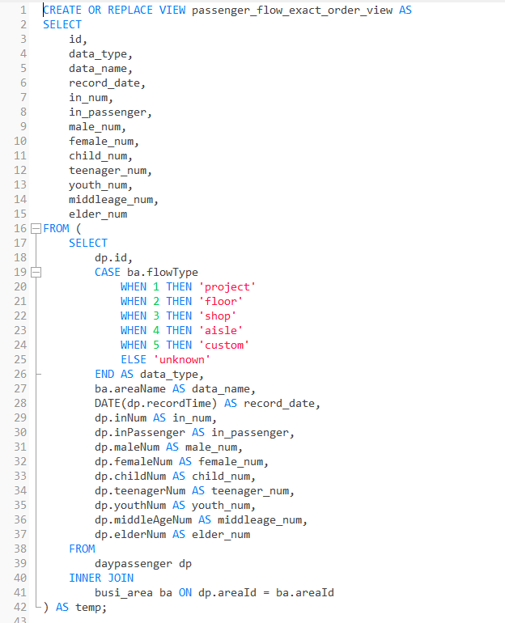
天数据实际查询效果如下
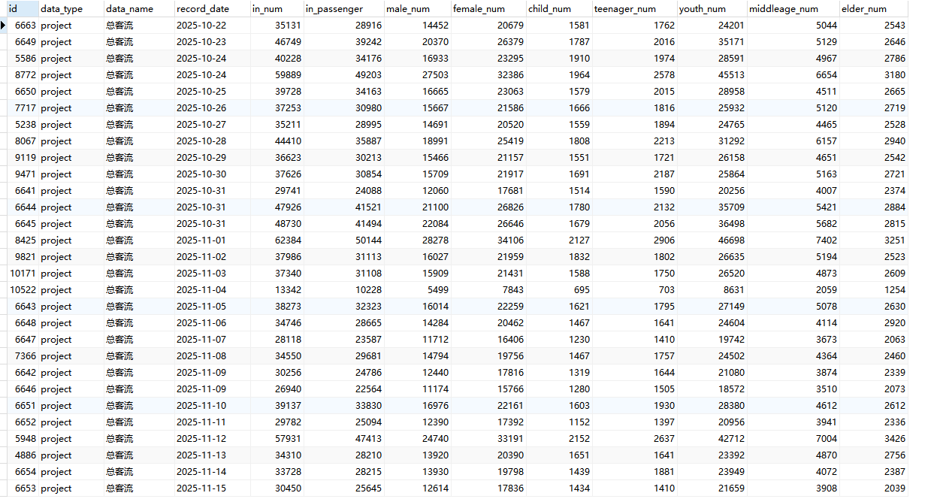

SQL：

CREATE OR REPLACE VIEW passenger_flow_exact_order_view AS
SELECT
id,
data_type,
data_name,
record_date,
in_num,
in_passenger,
male_num,
female_num,
child_num,
teenager_num,
youth_num,
middleage_num,
elder_num
FROM (
SELECT
dp.id,
CASE ba.flowType
WHEN 1 THEN 'project'
WHEN 2 THEN 'floor'
WHEN 3 THEN 'shop'
WHEN 4 THEN 'aisle'
WHEN 5 THEN 'custom'
ELSE 'unknown'
END AS data_type,
ba.areaName AS data_name,
DATE(dp.recordTime) AS record_date,
dp.inNum AS in_num,
dp.inPassenger AS in_passenger,
dp.maleNum AS male_num,
dp.femaleNum AS female_num,
dp.childNum AS child_num,
dp.teenagerNum AS teenager_num,
dp.youthNum AS youth_num,
dp.middleAgeNum AS middleage_num,
dp.elderNum AS elder_num
FROM
daypassenger dp
INNER JOIN
busi_area ba ON dp.areaId = ba.areaId
) AS temp;

